隔 爆 热电偶使用说明书
INSTRUCTIONS OF Explosion-proof THERMOCOUPLE

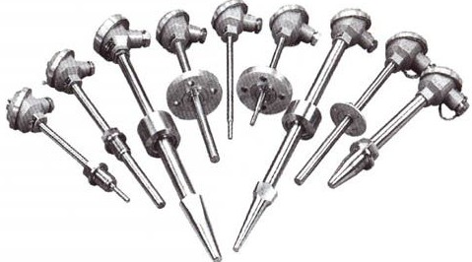

网址:http://www.ahtkzk.com 销售热线:0550-7539918

隔爆热电偶
Explosion-proof Thermocouple
应用
通常和显示仪表、记录仪表、电子计算机等配套使用。直接测量生产现场存在碳氢化合物等爆炸物的0℃～1300℃范围内液体、蒸汽和气体介质以及固体表面温度。

特点
1、多种隔爆形式, 隔爆性能好；
2、压簧式感温元件、抗振性能好；
3、测量范围大；
4、机械强度高，耐压性能好；

工作原理
隔爆热电偶是利用间隙爆原理，设计具有足够强度的接线盒等部件，将所有会产生火花、电弧和危险温度的零部件都密封在接线盒腔内，当腔内发生爆炸时，能通过接合面间隙熄火和冷却，使爆炸后的火焰和温度传不到腔外，从而进行隔爆。

主要技术参数
产品执行标准
IEC584
GB/T16839-1997
JB/T5518-1991
GB3836

常温绝缘电阻
热电偶在环境温度为20±15℃，相对湿度不大于80%，试验电压为500±50V（直流）电极与外套管之间的绝缘电阻≥1000MΩ·m
Application
It is usually connected with display meter,recording meter and computer,etc,to directly measure temperature of liquid,vapor,gas and solid surface ranging from 0℃to 1300 ℃with explosives such as hydrocarbon on production spot.

Features
1 Various explosion-proof types,good explosion-proof performance
2 Spring thermal element with good shock-resitant performance
3 wide measuring range
4 High mechanical strength.good pressure -resistant performance

Operation Theory
Explosion-proof thermocouple has a junction box of enough strength with gaps inside it.All spare parts which might produce spark,electric arc.and dangerous high temperature are sealed in the junction box,When explosion within the box happens,fire and high temperature caused by explosion could be extincted and cooled with the gap.Thus,explosion separation could be realized.

Main Technical Parameters
Executive Standand
IEC584
GB/T16839-1997
JB/T5518-1991
GB3836

Insulation Resitance at Normal Temperature
The insulation resistance between electrode and protection tube of the thermocouple shall be no less than 1000MΩ.m under condition that environment temperatrue is20±15℃,ralative humidity is no more than 80%,and testing volting isD.C.500V±50V

测温范围及允差
Measuring range & Tolerance

型号  Type | 分度号  Graduation | 允差等级 Tolerance Class
型号  Type | 分度号  Graduation | I |  | II
型号  Type | 分度号  Graduation | 允差值  Tolerance Value | 测温范围℃  Measuring Range | 允差值  Tolerance Value | 测温范围℃  Measuring Range
WRN | K | ±1.5℃ | -40~+375 | ±2.5℃ | -40~+333
WRN | K | ±0.004│t│ | 375~1000 | ±0.0075│t│ | 333~1200
WRM | N | ±1.5℃ | -40~+375 | ±2.5℃ | -40~+333
WRM | N | ±0.004│t│ | 375~1000 | ±0.0075│t│ | 333~1200
WRE | E | ±1.5℃ | -40~375 | ±2.5℃ | -40~333
WRE | E | ±0.004│t│ | 375~800 | ±0.0075│t│ | 333~900
WRF | J | ±1.5℃ | -40~+375 | ±2.5℃ | -40~+333
WRF | J | ±0.004│t│ | 375~750 | ±0.0075│t│ | 333~750
WRC | T | ±0.5℃ | -40~+125 | ±1.0℃ | -40-133
WRC | T | ±0.004│t│ | 125~350 | ±0.0075│t│ | 133-350

防爆分组形式
Indication of Explosion-proof Function
□ Ⅱ □ T □

温度组别:T1-T6 Temperature Group:T1-T6
隔爆等级:A、B、C Explosion-proof Class:A、B、C

工厂用电气设备 Electric Equipment for Plant
d:隔爆型 Explosion Separation Type
ia:本质完全型 Intrinsic Type

电气设备类别 Electric Equipment Category
Ⅰ类——煤矿井下用电气设备 Ⅰ- Electric Equipment for Coal Mine Well
Ⅱ类——工厂用电气设备 Ⅱ- Electric Equipment for Plant

隔爆等级 Explosion-proof Class
隔爆热电偶的防爆等级按其使用爆炸性气体混 It is divided into grade A、Band C according to maximum test
合物最大试验安全间隙分为A、B、C三级。 safety gap in explosive gas compound.
类别  Category | 级别  Class | 最大试验安全间隙（MESG）mm  Max.Test Safety Gap
II | A | 0.9≤MESG
II | B | 0.5＜MESG＜0.9
II | C | MESG≤0.5

温度组别 Temperature Group
隔爆热电偶的温度组别按其外露部分允许最高 It includes T1-T6 according to the maximum
面温度分为T1-T6 temperature of open part.
温度组别  Temperature Group | 允许最高表面温度℃  Max. Surface Temperature Allowed
T1 | 450
T2 | 300
T3 | 200
T4 | 135
T5 | 100
T6 | 85

防爆级别：Explosion-proof Class

EXd II□T□
EXia II□T□

防护等级：Protection Class
IP65

接线盒形式
Junction Box
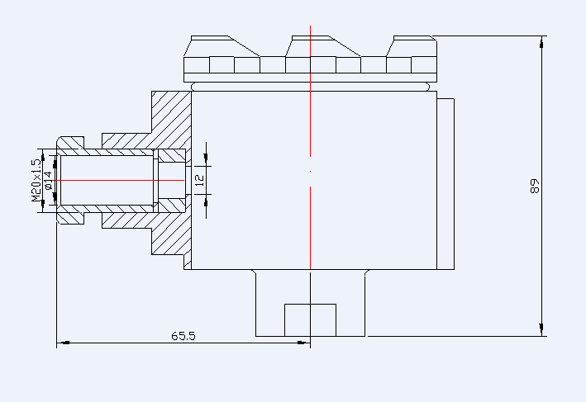

EXd II□T□
EXia II□T□

型号命名方法
Type Naming Method

W R N 2 — 2 4 0 G 典型型号示例 Model Examlple
W 温度仪表 W Temperature Instrument
R 热电偶 R Thermocouple
感温元件材料Thermal Element Material
M镍铬硅-镍硅NiCrSi-NiSi N镍铬-镍硅 NiCr-NiSi E镍铬-铜镍 NiCr-CuNi F铁-铜镍Fe-CuNi C铜-铜镍Cu-CuNi
偶丝对数Filament无单支blank Simplex2双支2 Duplex
接线盒形式Junction Box4 防爆式4 Explosion-proof Type
安装固定形式Mounting & Fixing1 无固定装置1 Without Fixing Device2 固定螺纹2 Threaded Head with Fixed Fastener4固定法兰4 Fixed Flange5活络管接头式5 Elbow Tube Connector7直形螺纹管接头式7 Straight Tube Connector8固定螺纹管接头式8 Fixed Threaded-tube Connector9活动螺纹管接头式9 Movable Threaded-tube Connector
保护管直径Protection Tube Diameter0 Φ 160 Φ 16
工作端形式Measuring EndG 变截面G Varible Cross Section

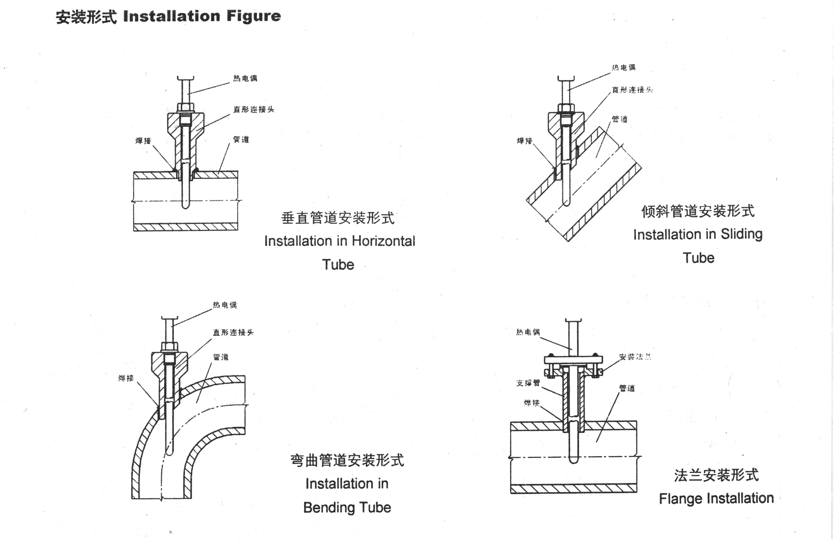

连接头 Straight Connector

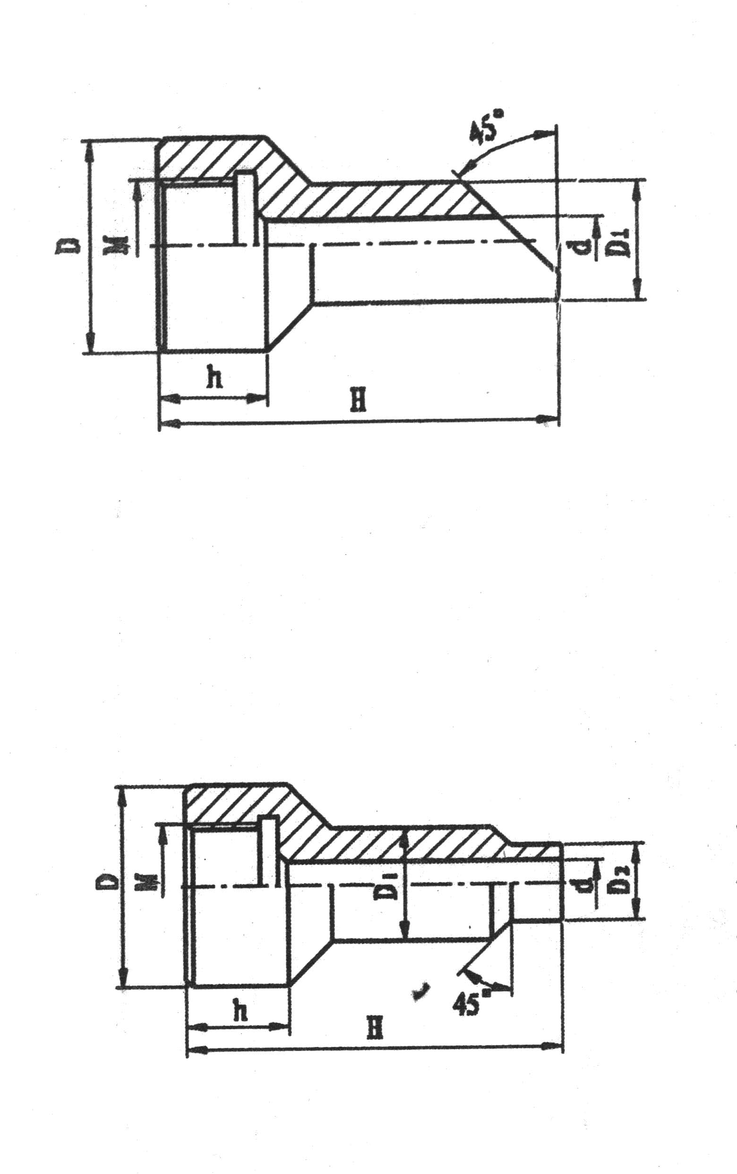
代号Code | M | D | D₁ | d | h | H
TH49A | M27*2 | Φ47 | Φ28 | Φ18 | 30 | 90
TH49B | M33*2 | Φ55 | Φ36 | Φ24 | 30 | 150
TH49C | NPT1/2 | Φ39 | Φ27 | Φ16 | 30 | 90
TH49D | NPT3/4 | Φ47 | Φ31 | Φ20 | 35 | 90
TH49E | NPT1 | Φ47 | Φ41 | Φ30 | 40 | 150

代号 Code | M | D | D₁ | D₂ | d | h | H
TH48A | M12*1.5 | Φ32 | Φ18 | Φ12 | Φ7 | 27 | 60.120
TH48B | M16*1.5 | Φ36 | Φ18 | Φ14 | Φ7 | 27 | 80
TH48C | M20*1.5 | Φ40 | Φ18 | Φ14 | Φ7 | 27 | 60
TH48D | M27*2 | Φ47 | Φ28 | Φ22 | Φ17 | 32 | 60
TH48E | M33*2 | Φ55 | Φ36 | Φ30 | Φ21 | 34 | 120
TH48F | NPT1/2 | Φ39 | Φ27 | Φ21 | Φ16 | 35 | 60  120
TH48G | NPT3/4 | Φ47 | Φ31 | Φ25 | Φ20 | 40 | 60  120
TH48H | NPT1 | Φ47 | Φ41 | Φ35 | Φ30 | 45 | 60  120

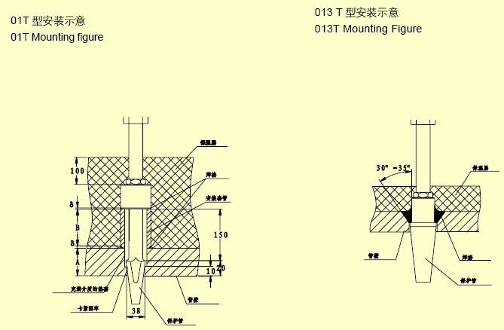
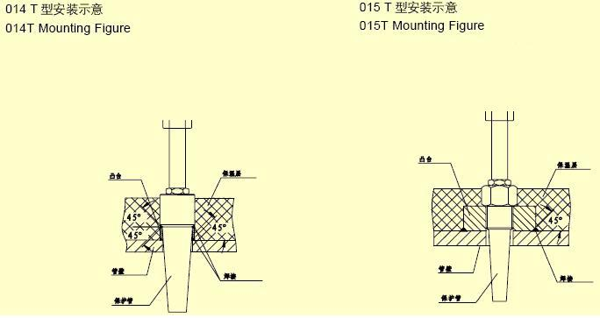

运输与贮存

热电偶及其附件在安装前,必须贮存在不受震动和碰撞的地方。最合适的贮存场所条件为环境温度10-35℃，相对湿度不大于80%，周围空气中不应含有可能使仪表零件腐蚀的介质。
热电阻在长距离运输过程中应仔细的包装好。
Storage and transportation
Before fixing,the thernmocouple and its accesscries should be stored away from range shock .the suitable conditions for storage areas follows:temp form 10℃to 35℃ relative humidity less than 80%;awayfrom the corrosive circumstances.
During long-distance transportation,the thermcouple should be wellpackaged.

可能发生的故障及修理

序号 | 故障现象 | 可能原因 | 修理方法
1 | 热电动势比实际应有的小（测量仪表示值偏低） | （1）热电偶内部电极漏电（短路）。  （2）热电偶内部潮湿。  （3）热电偶接线盒内接线短路。  （4）补偿导线短路。  （5）热电偶热电极变质或测量端损坏。  （6）补偿导线与热电偶的种类配置错误。  （7）补偿导线与热电极的极性接反。  （8）热电偶安装位置或受热长度不当。  （9）热电偶参比端温度过高。  （10）热电偶种类与仪表刻度不一致。 | （1）将热电偶的热电极取出，检查漏电原因，若因潮湿引起，应将热电极烘干，若是因保护管绝缘不良引起，应即予更换。  （2）将热电偶之热电极取出，把热电偶保护管和热电极分别烘干，并检查保护套管是否漏气，漏水等情况，对不合格的保护套管应予更换。  （3）打开接线盒盖，清洁接线板，消除造成断路的原因，把接线盒严密拧紧。  （4）将短路处重新缘缘或更换补偿导线。  （5）把变质部分剪去，重新焊接测量端或更换新的热电极。  （6）换成与热电偶同种类的补偿导线。  （7）重新改接。  （8）改变安装位置或方法及插入深度。  （9）准确地进行参比端温度补偿。  （10）更换热电偶及补偿导线，使之与测量仪表种类相同。
2 | 热电动势比实际应有的大（测量仪表示值偏高） | （1）热电偶种类用错，与测量仪表不符。 | （1）更换热电极，使之与测量仪表相符。

序号 | 故障现象 | 可能原因 | 修理方法
2 | 热电动势比实际应有的大（测量仪表示值偏高） | （2）补偿导线与热电偶种类不符。  （3）热电偶安装方法、位置或插入深度不当。 | （2）换成与热电偶同类的补偿导线。  （3）改变热电偶安装方法、位置或插入深度。
3 | 测量仪表的示值不稳定（在测量仪表无故障情况下） | （1）热电偶接线柱和热电极接触不良。  （2）热电偶有断续短路或断续接地现象。  （3）热电极已断，或将断未断而有时断时连现象。  （4）热电偶安装不牢固，发生摆动。  （5）补偿导线有接地、断续路或断路现象。 | （1）清洁接线盒和热电偶端部重新连接好。  （2）将热电极从保护管中取出，找出断续短路或接地地方，加以排除。  （3）重新焊接断开处，并检查其特性有否改变，对不合要求的应予更换。  （4）将热电偶牢固安装。  （5）找出接地、断续短路处加以修理或更换新的补偿导线。
4 | 热电偶热电动势变化 | （1）热电极变质  （2）热电偶的安装位置或方法不当  （3）热电偶保护管表面积垢过多。 | （1）更换新电极。  （2）改变安装位置或方法。  （3）拆下热电偶，清除保护管外面积垢。

Troubleshoting

order | Trouble | Possible cause | Remedy
1 | The thermoemf is less than the practicai value (the readings of the display decice lower than the practical value) | (1) The thermocouple is short circuited.  (2)there is moisture within the thermocouple.  (3)the terminal in the terminal head shortcircuited.  (4)The compensating wire shortcircuited.  (5)Thermoelements have been deteriorated or measuring junction or measuring junction has been dmaged.  (6)The compensating wires do not match the thermocouple. | (1)Take out and check thermoelements,if is caused by dampdry out the trermelements;if it is caused by poor insulation, porcelain tubes should be replaced.  (2)Take out the thermoelements and dry out the protective tube and the thermoelements separately,then check the leakage of protective tube should be replaced.  (3)Open the terminal head and clean the cause of shortcircuit, then terminal head.  (4)nsulate the short-circuited part or change the compensation wires.  (5)Cut the deteriorated part off and  resoldered the measuring junction or replace the thermoelements.  (6)Use appropriate compensating wires.

order | Trouble | Possible cause | Remedy
1 |  | (7)The reverse polarity between the comoerstting wire and thermoelement  (8)Fixing place or heated length is not approriate.  (9)the temp atreference junction is too high.  (10)The type of thermocouple is not identical with the graduation of display  derice | (7)Make reconnection correctly.  (8)Change the fixing place or method and insert depth.  (9)Compensate the temp,at reference junction correctly.  (10)Change the thermocouple and compensating wires to match measuring instuments.
2 | The thermoEMF  is greater than the practical val-ue(the display value is higher than the practial value) | (1)The type of thermocople do not conform to the meter.  (2)The compensating cables do not conform to the thermocouple type.  (3)The fixing method place and insert depth is not proper. | (1)Clean the terminal box and the ends of thermoelements and reconnect them.  (2)Take out the elements from the protective tube and eliminiate the cause.  (3)Joint the broken thermo
3 | The reding of the display instrment are not stable(without failures) | (1)Poor contact between terminal and thermoelement for the thermocouple.  (2)The thermocouple is in intermittent shortcircuit or  earthing condition. | (1)Change the thermocouple to match the meter.  (2)Change the compersating cable

order | Trouble | Possible cause | Remedy
3 |  | (3)The thermoelements have broken or is on and off fixed firmly.  (4)The thermocouple is not fixed firmly.  (5)The compensating wire been has earthedshotcircuited or broken intermittly. | (3)Change the method,place and insert depth.elements and check its property.  Replace it when necessary.  (4)Repair or replace the compensating wire
4 | The thermoemf is varying | (1)The thermoelement has deteriorated.  (2)The fixing place or method is not appropriate.  (3)More scale depositad on the surface of protective tube. | (1)Replace it with a new one.  (2)Change the place or method.  (3)Remove the thermocouple and clean outside wall of the protactive tube.

注：当发生以上故障情况时，应将补偿导线和接线盒分开，分别检查热电偶与补偿导线，待确定故障后，再进行处理。
note:When above failures happen in the thermocouple,campensating wire shoud be disconnected from the terminal head firstly,then check the thermocouple and compensatingcables separately and handle the failure when it is determined.

