防 爆 热 电 阻 使 用 说 明 书
INSTRUCTIONS OF Explosion-proof
THERMAL RESISTANCE

网址:http://www.ahtkzk.com 销售热线:0550-7539918

隔爆热电阻
Explosion-proof THERMAL RESISTANCE
应用
通常和显示仪表、记录仪表、电子计算机等配套使用。直接测量生产现场存在碳氢化合物等爆炸物的-200℃～ 500℃范围内液体、蒸汽和气体介质以及固体表面温度。

特点
1、多种隔爆形式, 隔爆性能好；
2、压簧式感温元件、抗振性能好；
3、测量精确度高；
4、进口薄膜电阻元件，性能可靠稳定；

工作原理
隔爆热电阻是利用间隙爆原理，设计具有足够强度的接线盒等部件，将所有会产生火花、电弧和危险温度的零部件都密封在接线盒腔内，当腔内发生爆炸时，能通过接合面间隙熄火和冷却，使爆炸后的火焰和温度传不到腔外，从而进行隔爆。

主要技术参数
产品执行标准
IEC751
JB/T8622-1997
JB/T8623-1997
JB/5518-1991

常温绝缘电阻
热电阻在环境温度为15-35℃，相对湿度不大于80%，试验电压为10-100V（直流）电极与外套管之间的绝缘电阻≥100MΩ
Application
It is usually connected with display meter,recording meter and computer,etc,to directly measure temperature of liquid,vapor,gas and solid surface ranging from -200℃to 500 ℃with explosives such as hydrocarbon on production spot.

Features
1 Various explosion-proof types,good explosion-proof performance
2 Spring thermal element with good shock-resitant performance
3 High measuring accuracy;
4 Imported film resistor with high reliability and stability

Operation Theory
Explosion-proof thermocouple has a junction box of enough strength with gaps inside it.All spare parts which might produce spark,electric arc.and dangerous high temperature are sealed in the junction box,When explosion within the box happens,fire and high temperature caused by explosion could be extincted and cooled with the gap.Thus,explosion separation could be realized.

Main Technical Parameters
Executive Standand
IEC751
JB/T8622-1997
JB/T8623-1997
JB/5518-1991

Insulation Resistance at Normal Temperature
The insulation resistance between electrode and protection tube of the thermocouple shall be no less than 100MΩ.m under condition that environment temperatrue is15-35℃,ralative humidity is no more than 80%,and testing volting isD.C.10-100V

测温范围及允差
Measuring range & Tolerance
型号  Type | 分度号  Graduation | 测量范围  Measuring Range | 精度等级  Accuracy | 允许偏差  Toleravce
WZP | Pt100 | -200～500 | A级 | ±（0.15+0.002）︱t︱
WZP | Pt100 | -200～500 | B级 | ±（0.30+0.005）︱t︱
WZC | Cu50  Cu100 | -50～100 | —— | ±（0.30+0.006）︱t︱

注：t为感温元件实测温度绝对值 Rcmarks:t is absoiute vabue actually tested with thermal sensor

防爆分组形式
Indication of Explosion-proof Function
□ Ⅱ □ T □

温度组别:T1-T6 Temperature Group:T1-T6
隔爆等级:A、B、C Explosion-proof Class:A、B、C

工厂用电气设备 Electric Equipment for Plant
d:隔爆型 Explosion Separation Type
ia:本质完全型 Intrinsic Type

电气设备类别 Electric Equipment Category
Ⅰ类——煤矿井下用电气设备 Ⅰ- Electric Equipment for Coal Mine Well
Ⅱ类——工厂用电气设备 Ⅱ- Electric Equipment for Plant

隔爆等级 Explosion-proof Class
隔爆热电阻的防爆等级按其使用爆炸性气体混 It is divided into grade A、Band C according to maximum test
合物最大试验安全间隙分为A、B、C三级。 safety gap in explosive gas compound.
类别  Category | 级别  Class | 最大试验安全间隙（MESG）mm  Max.Test Safety Gap
II | A | 0.9≤MESG
II | B | 0.5＜MESG＜0.9
II | C | MESG≤0.5

温度组别 Temperature Group
隔爆热电阻的温度组别按其外露部分允许最高 It includes T1-T6 according to the maximum
面温度分为T1-T6 temperature of open part.
温度组别  Temperature Group | 允许最高表面温度℃  Max. Surface Temperature Allowed
T1 | 450
T2 | 300
T3 | 200
T4 | 135
T5 | 100
T6 | 85

型号命名方法
Type Naming Method

W Z P 2 — 2 4 0 G 典型型号示例 Model Examlple
W 温度仪表 W Temperature Instrument
Z 热电阻 R Thermal Resistance
感温元件材料Thermal Element Material
P 铂P Pt C铜C Cu
元件对数Filament无单支blank Simplex2双支2 Duplex
接线盒形式Junction Box4 防爆式4 Explosion-proof Type
安装固定形式Mounting & Fixing1 无固定装置1 Without Fixing Device2 固定螺纹2 Threaded Head with Fixed Fastener4固定法兰4 Fixed Flange5活络管接头式5 Elbow Tube Connector7直形螺纹管接头式7 Straight Tube Connector8固定螺纹管接头式8 Fixed Threaded-tube Connector9活动螺纹管接头式9 Movable Threaded-tube Connector
保护管直径Protection Tube Diameter0 Φ 160 Φ 16
工作端形式Measuring EndG 变截面G Varible Cross Section

防爆级别：Explosion-proof Class
EXd II□T□
EXia II□T□

防护等级：Protection Class
IP65

接线盒形式
Junction Box

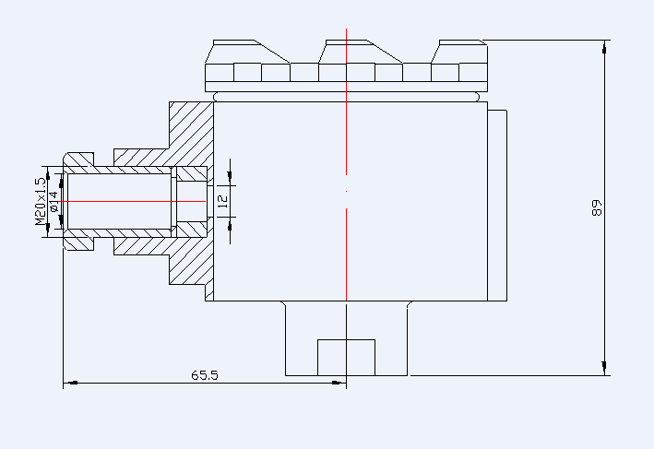
EXd II□T□
EXia II□T□

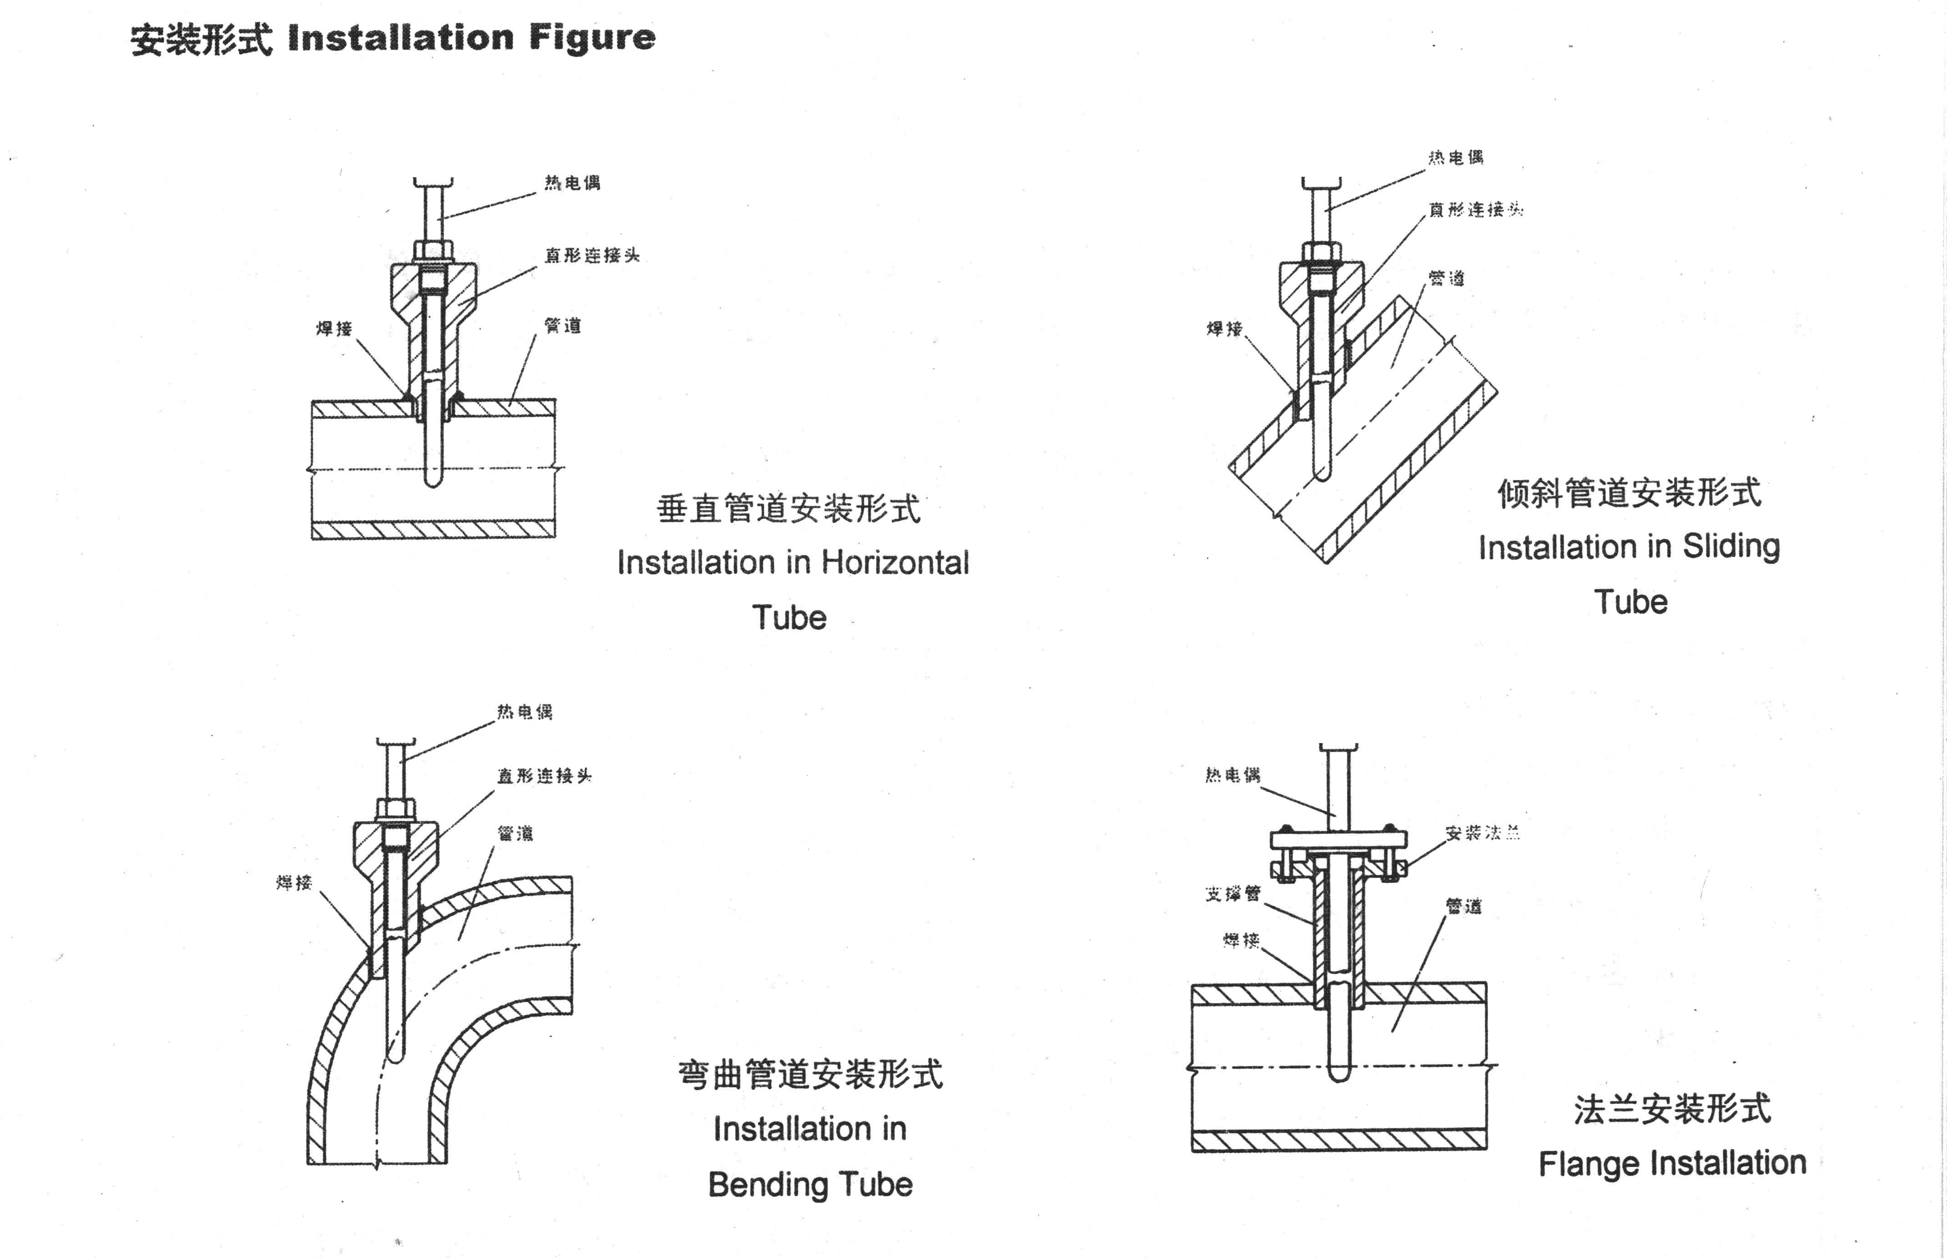

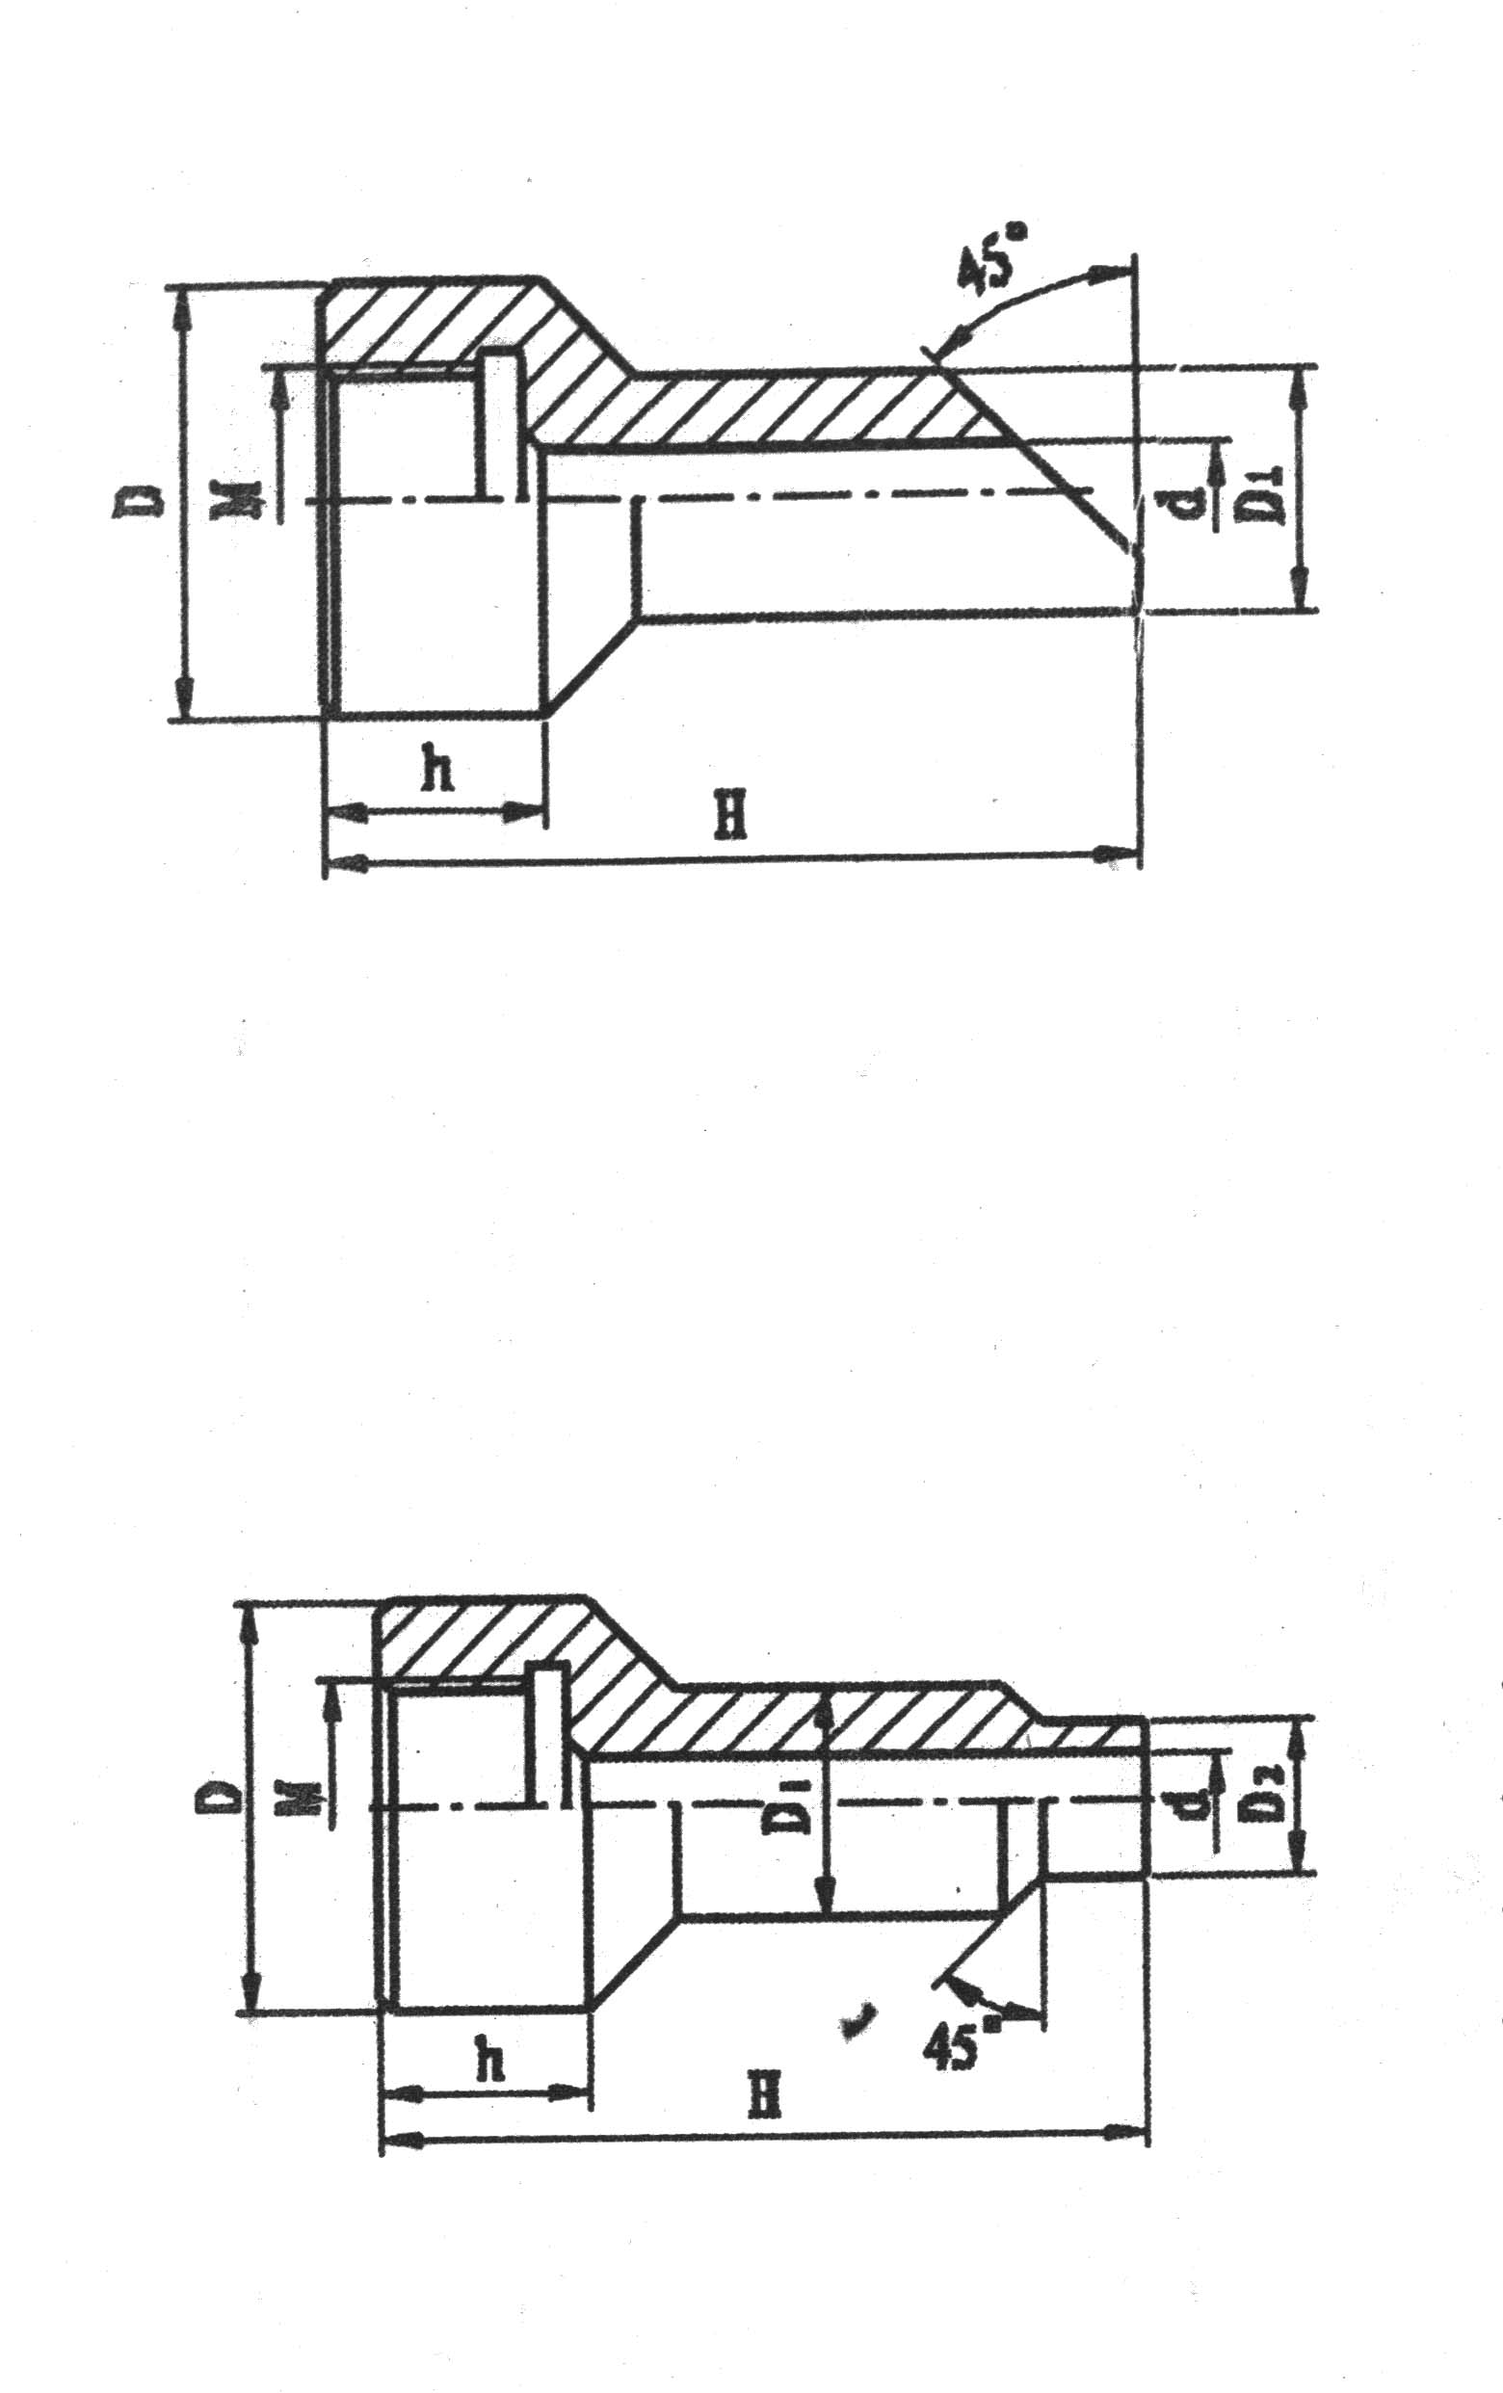

直接连接头 Straight Connector
代号Code | M | D | D₁ | d | h | H
TH49A | M27*2 | Φ47 | Φ28 | Φ18 | 30 | 90
TH49B | M33*2 | Φ55 | Φ36 | Φ24 | 30 | 150
TH49C | NPT1/2 | Φ39 | Φ27 | Φ16 | 30 | 90
TH49D | NPT3/4 | Φ47 | Φ31 | Φ20 | 35 | 90
TH49E | NPT1 | Φ47 | Φ41 | Φ30 | 40 | 150

代号 Code | M | D | D₁ | D₂ | d | h | H
TH48A | M12*1.5 | Φ32 | Φ18 | Φ12 | Φ7 | 27 | 60.120
TH48B | M16*1.5 | Φ36 | Φ18 | Φ14 | Φ7 | 27 | 80
TH48C | M20*1.5 | Φ40 | Φ18 | Φ14 | Φ7 | 27 | 60
TH48D | M27*2 | Φ47 | Φ28 | Φ22 | Φ17 | 32 | 60
TH48E | M33*2 | Φ55 | Φ36 | Φ30 | Φ21 | 34 | 120
TH48F | NPT1/2 | Φ39 | Φ27 | Φ21 | Φ16 | 35 | 60  120
TH48G | NPT3/4 | Φ47 | Φ31 | Φ25 | Φ20 | 40 | 60  120
TH48H | NPT1 | Φ47 | Φ41 | Φ35 | Φ30 | 45 | 60  120

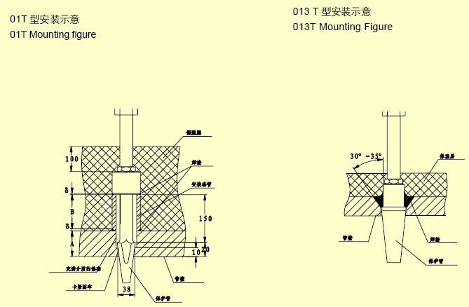
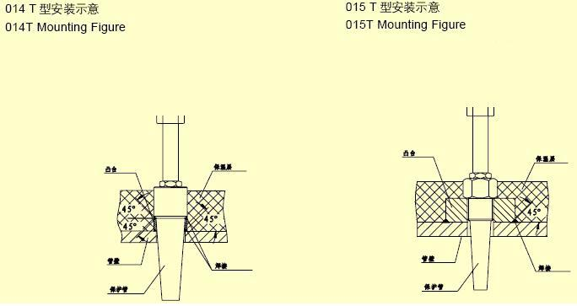

运输与贮存

热电阻及其附件在安装前,必须贮存在不受震动和碰撞的地方。最合适的贮存场所条件为环境温度10-35℃，相对湿度不大于80%，周围空气中不应含有可能使仪表零件腐蚀的介质。

热电阻在长距离运输过程中应仔细的包装好。

可能发生的故障及修理
序号 | 故障现象 | 可能原因 | 修理方法
1 | 显示仪表显示  值比实际值偏  低或示值不稳  定 | 保护管内有水或接  线盒内有金属屑、灰  尘或热电阻短路 | - 倒出水或清除灰尘，并将潮湿部分加以干燥处理；提高绝缘（不能火烤）。  - 用万用电表检查断路或接地的部位，并清除之。
2 | 显示仪表显示  值无限大 | 热电阻断路 | - 用万用电表检查断路部位，确定是连接导线还是感温元件断路。  - 如是感温元件断路应进行更换。
3 | 显示仪表显示  值下限值 | - 热电阻短路  - 显示仪表接线错误 | - 用万用电表检查确定短路部位，如是感温元件断路应进行修复或更换。  - 重新连接导线。

Storage and transportation
Thermal resistance and its annex to the installation, they must be stored in a place free from vibration and impact. The most appropriate conditions for ambient temperature storage sites 10-35 ℃, relative humidity of not more than 80% ambient air should not contain components that could cause corrosion of the media devices.
Thermal resistance in long-distance transportation process should be carefully packaged.

Troubleshoting

order | Trouble | Possible cause | Remedy
1 | Display Instrument displayed value than the actual value indication of low or unstable | Protection of water pipe or a terminal box with metal filings, dust or heat resistance short circuit | - pouring water or clear the dust, and some of them dry and wet processing; increased insulation (not roasted).  (2) a multimeter check the open circuit or grounded parts and to remove the.
2 | Display meter shows the value of infinity | The RTD is Circuit | - a multimeter check the open circuit position to determine the connecting wire or circuit temperature sensing element.  (2) the case of thermal circuit components should be replaced.
3 | Display Instrument Display lower limit of | - Thermal resistance short circuit  (2) shows the instrument wiring error | (1) Check with the multimeter to determine short-circuit position, the case of temperature sensing circuit components should be repaired or replaced.  (2) Re-connect wires.

